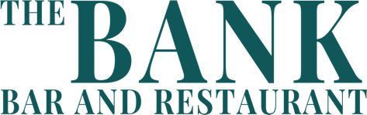
Booking Name:
Company Name:
Number of Guests:
Date of Booking:
Time of Booking:
 | NAME | MAIN MEAL | DRINK | ALLERGIES
1
2
3
4
5
6
7
8
9
10
11
12
13
14
15
16
17
18
19
20
21
22
23
24
25
26
27
28

Once completed please email to preorders@thebankoncollins.com.au

Please note, no split bills for groups of 10 or more.
Groups over 20 guests must pre-order.

